H.NO:2303A51807 BATCH:26

SCHOOL OF COMPUTER SCIENCE AND ARTIFICIAL INTELLIGENCE |  |  |  |  | DEPARTMENT OF COMPUTER SCIENCE ENGINEERING
Program Name: B. Tech |  |  |  | Assignment Type: Lab |  |  | Academic Year:2025-2026
Course Coordinator Name |  |  |  | Dr. Rishabh Mittal
Instructor(s) Name |  |  |  | Mr. S Naresh Kumar  Ms. B. Swathi  Dr. Sasanko Shekhar Gantayat  Mr. Md Sallauddin  Dr. Mathivanan  Mr. Y Srikanth  Ms. N Shilpa  Dr. Rishabh Mittal (Coordinator)  Dr. R. Prashant Kumar  Mr. Ankushavali MD  Mr. B Viswanath  Ms. Sujitha Reddy  Ms. A. Anitha  Ms. M.Madhuri  Ms. Katherashala Swetha  Ms. Velpula sumalatha  Mr. Bingi Raju
CourseCode |  |  | 23CS002PC304 | Course Title |  | AI Assisted Coding
Year/Sem |  |  | III/II | Regulation |  | R23
Date and Day  of Assignment |  |  | Week10 – Friday | Time(s) |  | 23CSBTB01 To 23CSBTB52
Duration |  |  | 2 Hours | Applicable to  Batches |  | All batches
Assignment Number:20.5(Present assignment number)/24(Total number of assignments)
 | Q.No. | Question |  |  |  |  |  | Expected Time  to complete
 | 1 | Lab 20 – Security Testing: Identifying Vulnerabilities in AI-Generated Code  Lab Objectives:  - Understand how to test AI-generated code for common security vulnerabilities.  - Learn to apply secure coding principles while analyzing AI outputs.  - Practice detecting risks such as SQL injection, XSS, hardcoded credentials, and weak encryption.  - Enhance code reliability and safety by using AI for secure refactoring. |  |  |  |  |  | Week10 - Friday
Task 1 – Password Storage Vulnerability Check
Task:
Analyze an AI-generated signup script for insecure password storage.
Instructions:
- Prompt AI to generate a Python user registration program.
- Check whether passwords are stored in plain text.
- Improve the script using hashing (bcrypt or hashlib).
Expected Output:
- A secure registration script with hashed password storage.

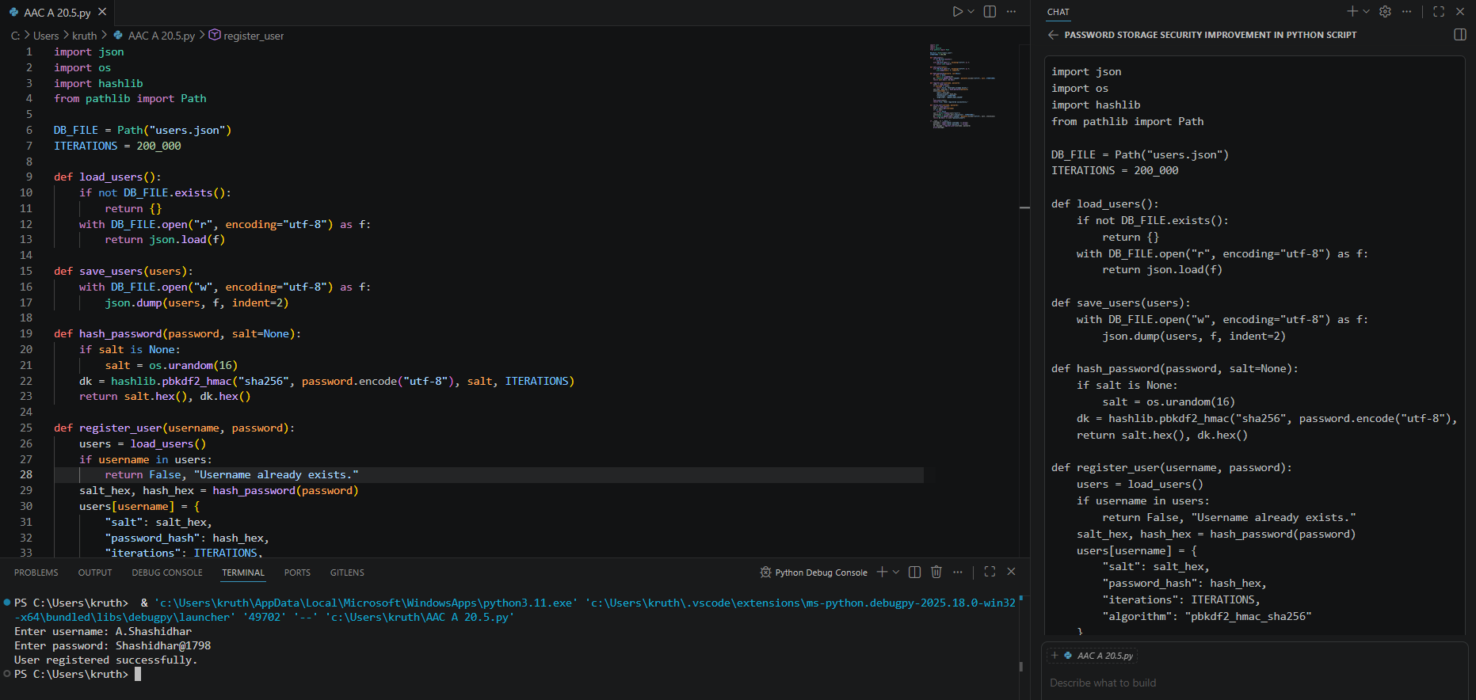

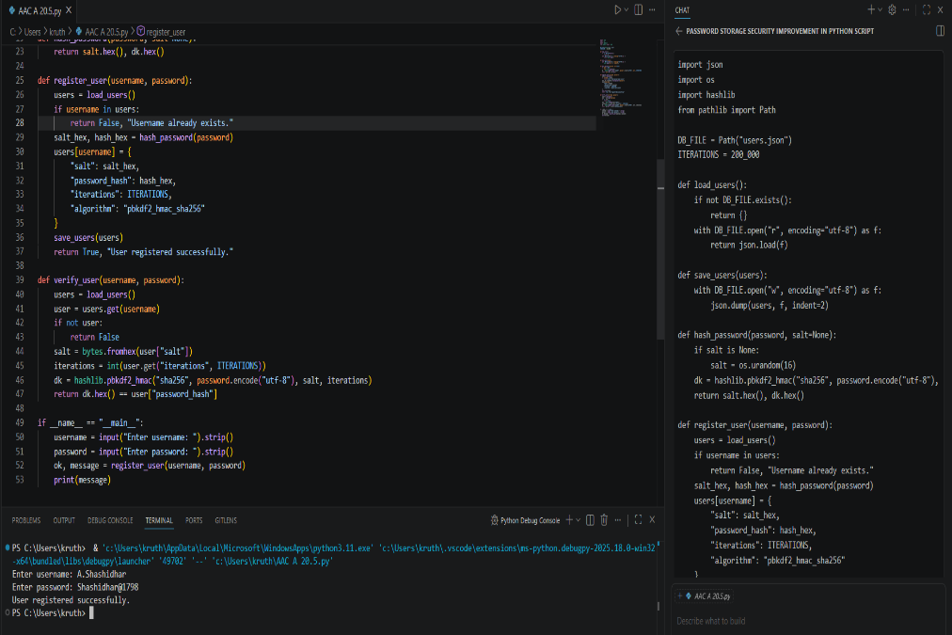

Task 2 – Hardcoded Secrets Detection
Task:
Evaluate AI-generated code for hardcoded API keys or credentials.
Instructions:
- Ask AI to generate a script that connects to an external API.
- Identify if API keys/passwords are written directly in code.
- Refactor using environment variables or config files.
Expected Output:
- A secure script with secrets managed properly.
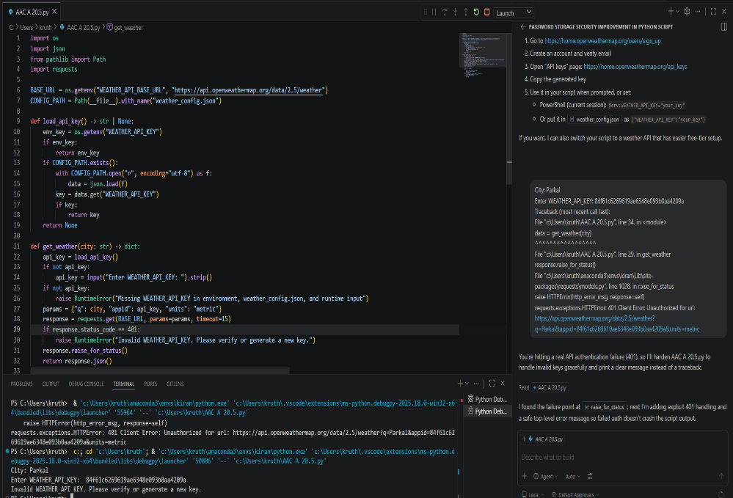

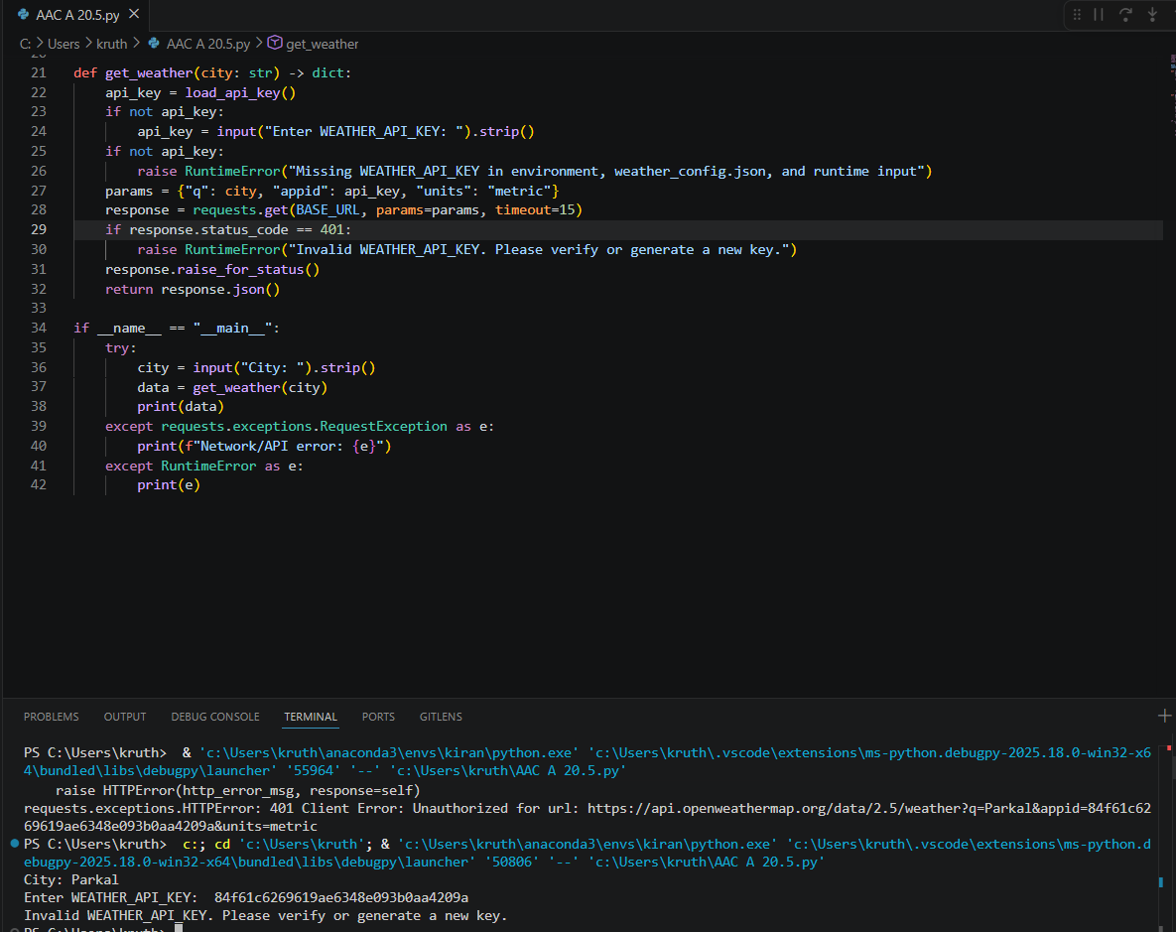

Task 3 – File Upload Security Validation
Task:
Test an AI-generated file upload program for unsafe file handling.
Instructions:
- Prompt AI to generate a Flask file upload example.
- Check for vulnerabilities like uploading executable files.
- Add validation for file type, size, and secure filename handling.
Expected Output:
- A secure file upload implementation.

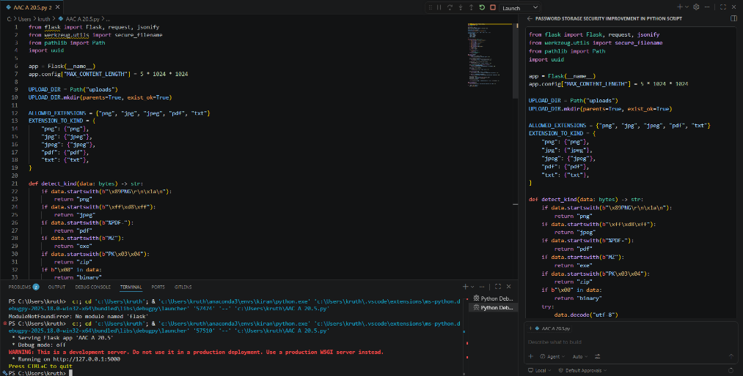
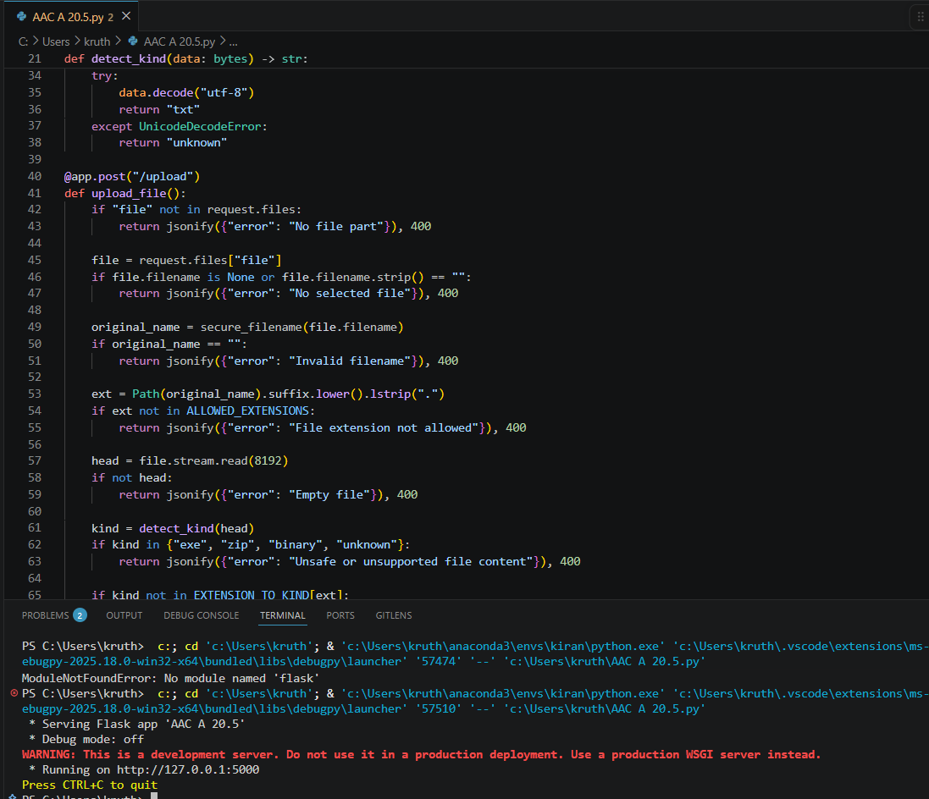

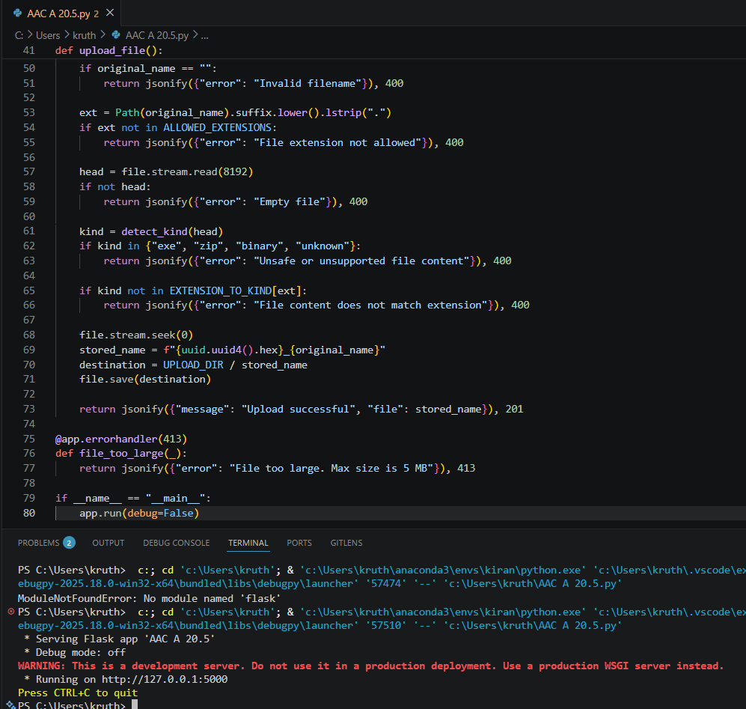
Task 4 – Command Injection Prevention
Task:
Analyze an AI-generated Python script that executes system commands.
Instructions:
- Ask AI to generate code using os.system() or subprocess.
- Identify command injection risks with user input.
- Fix using safe subprocess calls and input validation.
Expected Output:
- A secure command execution script.
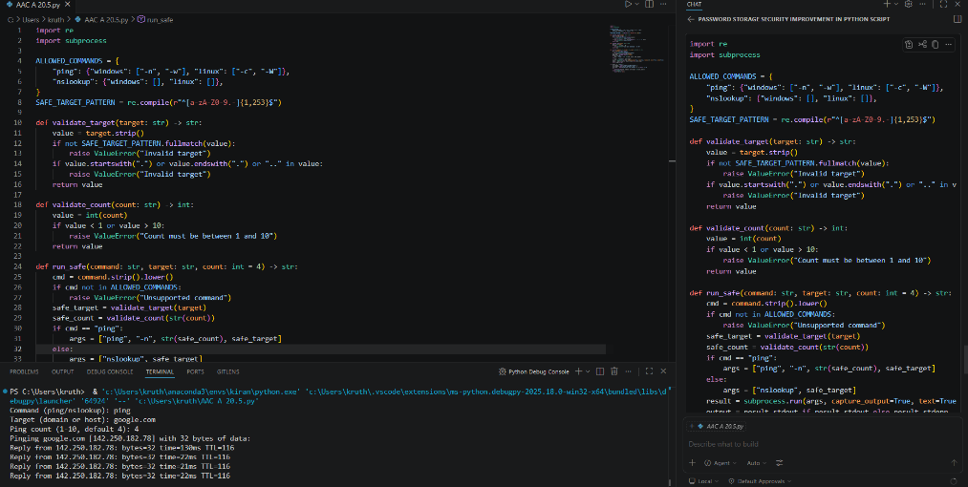
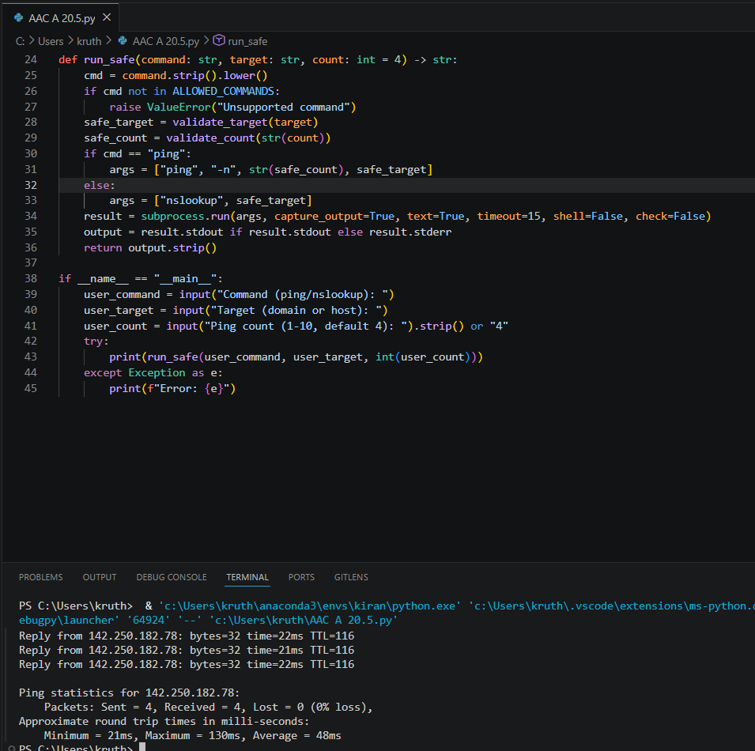

Task 5 – Secure Input Handling in Web Forms
Task:
Check AI-generated web form code for improper input validation.
Instructions:
- Ask AI to generate an HTML + Flask feedback form.
- Identify missing validation and unsafe rendering.
- Fix using server-side validation and sanitization.
Expected Output:
- A secure form resistant to injection attacks.
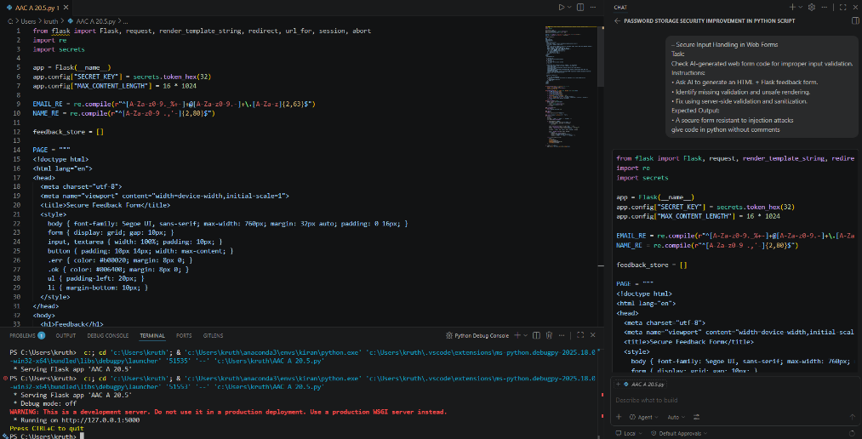
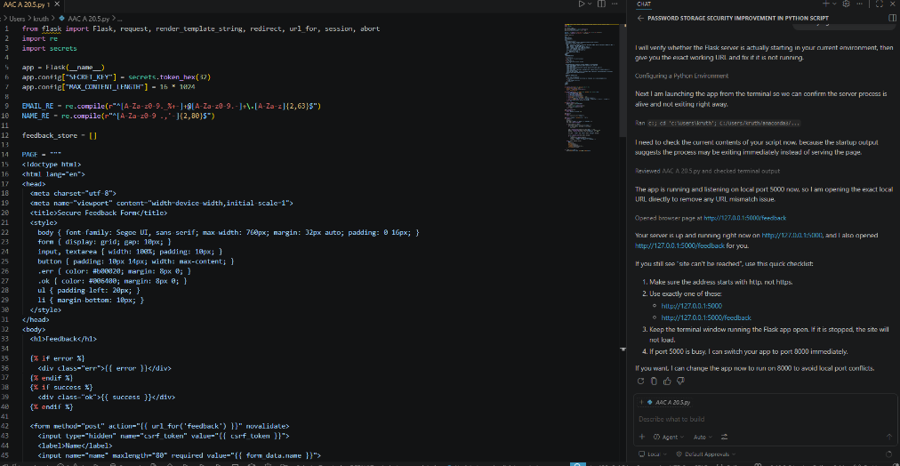

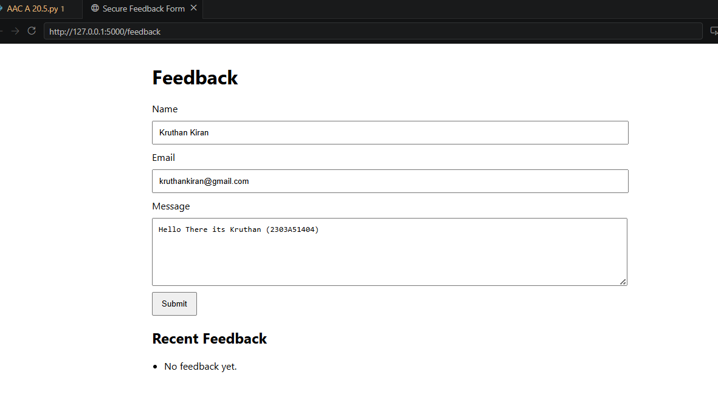
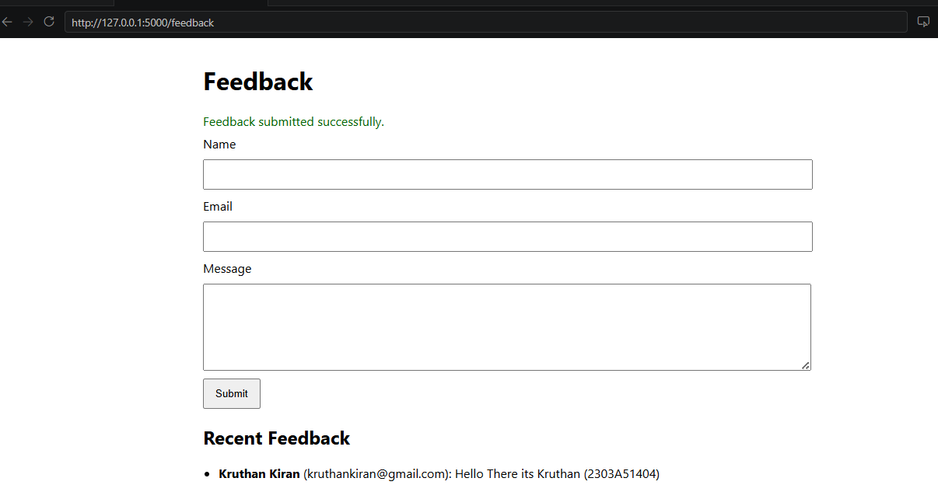

Note: Report should be submitted as a word document for all tasks in a single document with prompts, comments & code explanation, and output and if required, screenshots.

